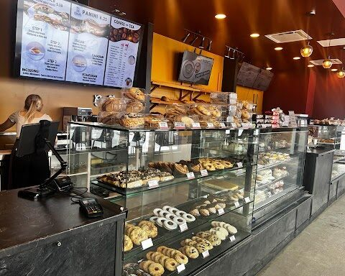
Home Baked
Web Development
Tshireletso Pakwe | ST10533502 | WEDE5020

Contents
Organisation Overview 2
Website Goals and Objectives 3
Current Website Analysis 4
Proposed Website Features and Functionality 5
Design and User Experience 6
Technical Requirements 11
Timeline and Milestones 12
Budget 13
References 14

Organisation Overview
Home Baked is a local bakery located in Durban North, KwaZulu-Natal. The business offers a variety of baked goods including cakes, cupcakes, bread, pastries and other sweet and savoury products. The historical information indicates that Home Baked has operated from 175 uMhlanga Rocks Drive and has served the local community with a range of baked products. The proposed website will provide the bakery with a central online presence where customers can access information about its products and services.
Target audience for this bakery is local residents, families, customers purchasing baked goods for special occasions and customers that are interested in custom cakes/product enquiries.

Website Goals and Objectives
The website’s 2 main goals are:
- Increase online visibility by providing customers with an easily accessible platform containing Home Baked’s products, business information and contact details.
- Improve customer enquiries by providing an online enquiry form and clear calls to action.
KPIs
- Website visits and page views.
- Number of enquiries submitted through the website.
- Number of visitors viewing the products page.
- Number of users accessing the contact page.

Current Website Analysis
Home Baked does not currently have a dedicated website listed in the available business information. Its existing online presence can therefore be improved by creating a central website that organizes its products, contact information and business details one location.

Proposed Website Features and Functionality
The website will include:
- Homepage with an introduction and featured products.
- About Us page containing the bakery’s background.
- Products page displaying available baked goods.
- Enquiry page for customer requests and custom orders.
- Contact page containing contact information, business hours, location/map and a contact form.
- Responsive navigation for desktop and mobile users.

Design and User Experience
The website will use a warm and welcoming bakery inspired design. A soft colour palette, clear typography and high-quality food photography will create an appealing visual identity. The navigation will be simple and consistent, allowing users to reach important information within a few clicks. Clear buttons such as “View Products” and “Make an Enquiry” will guide visitors through the website.
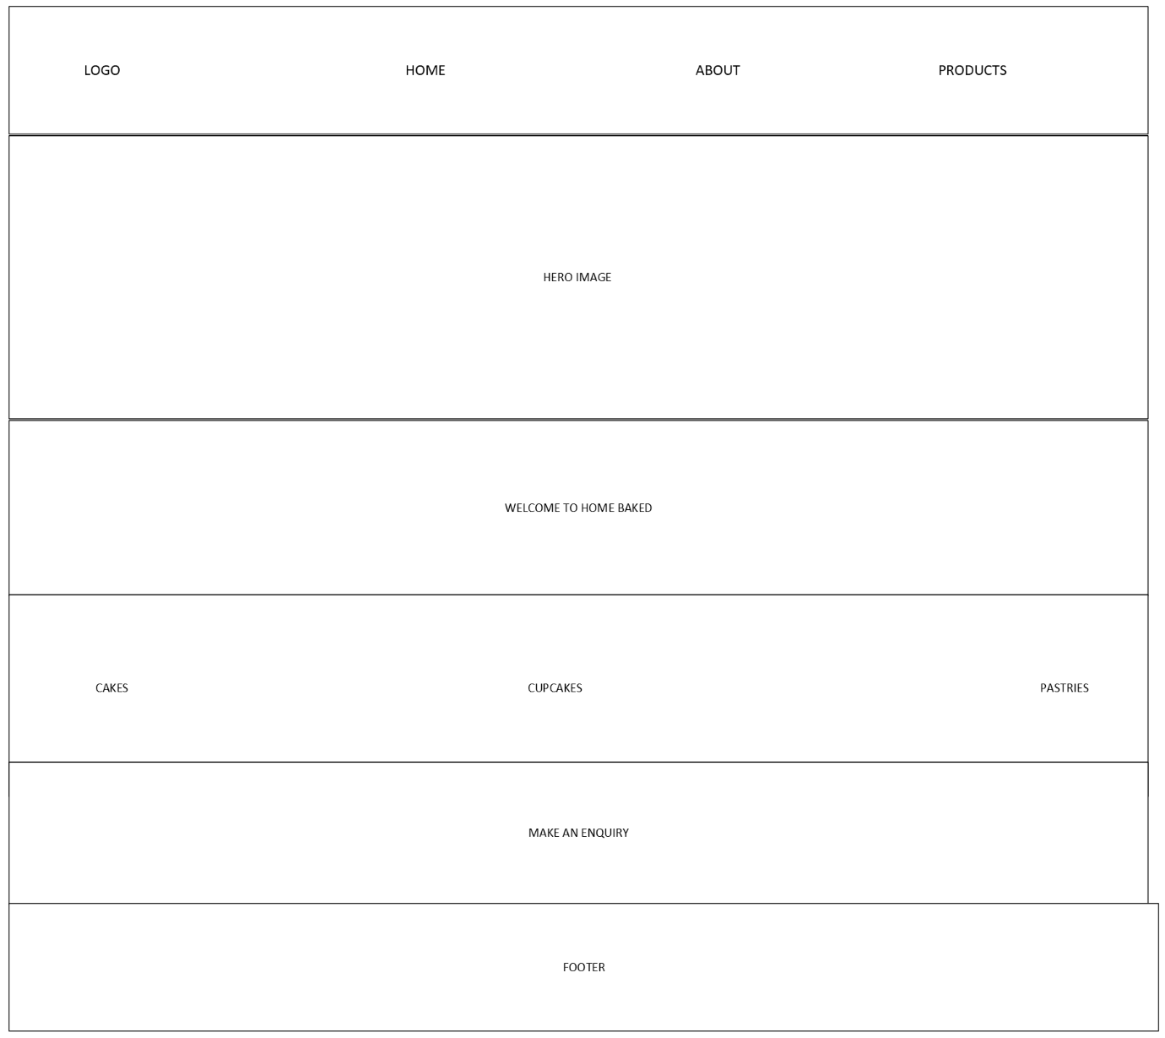
Figure 1: Home Baked homepage wireframe

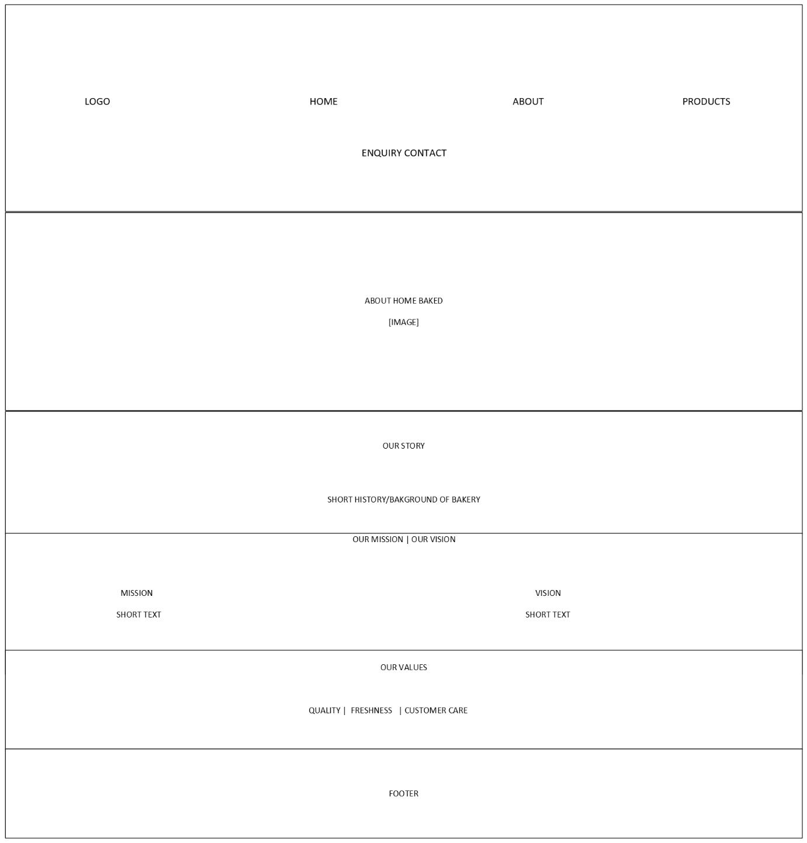
Figure 2: Home Baked About Us page wireframe
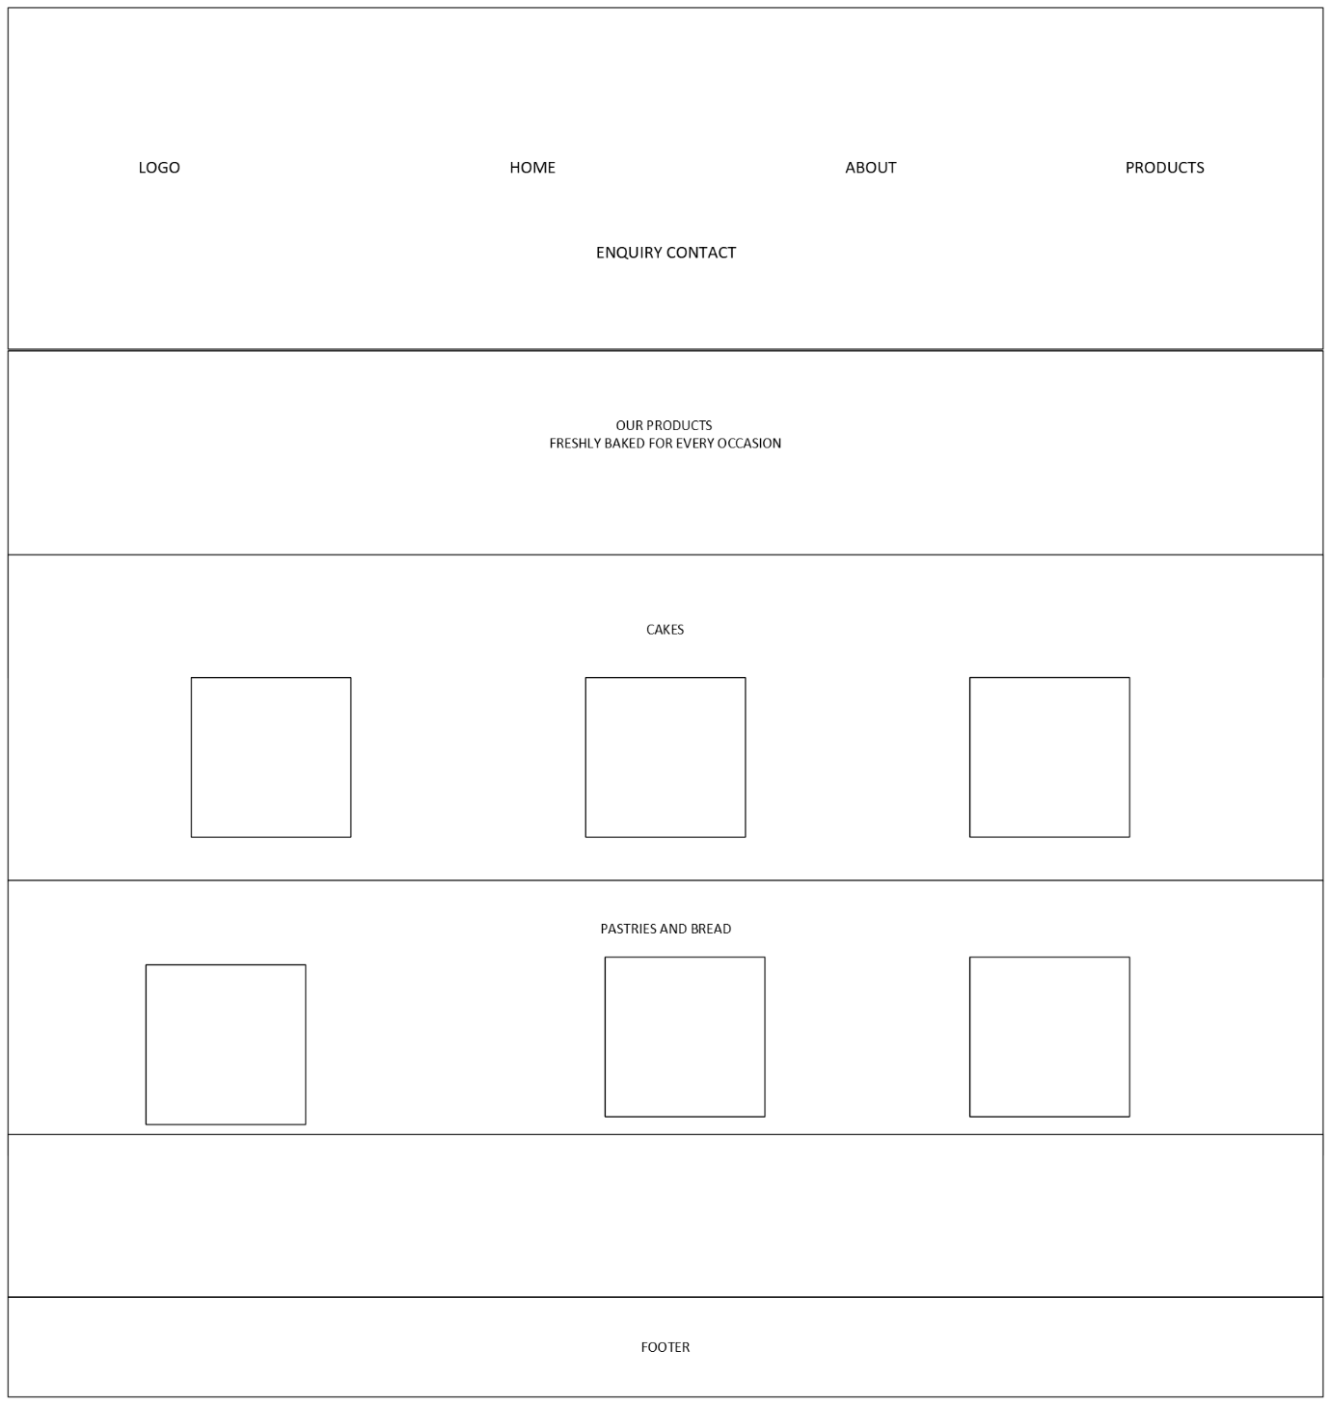
Figure 3: Home Baked Products page wireframe
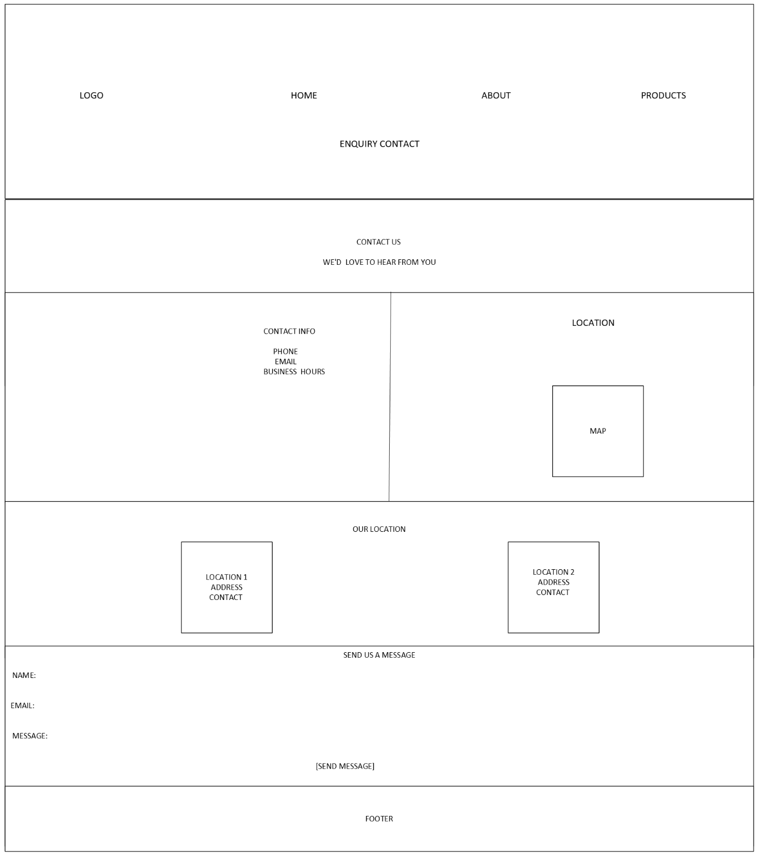
Figure 4: Home Baked Contact Us page wireframe
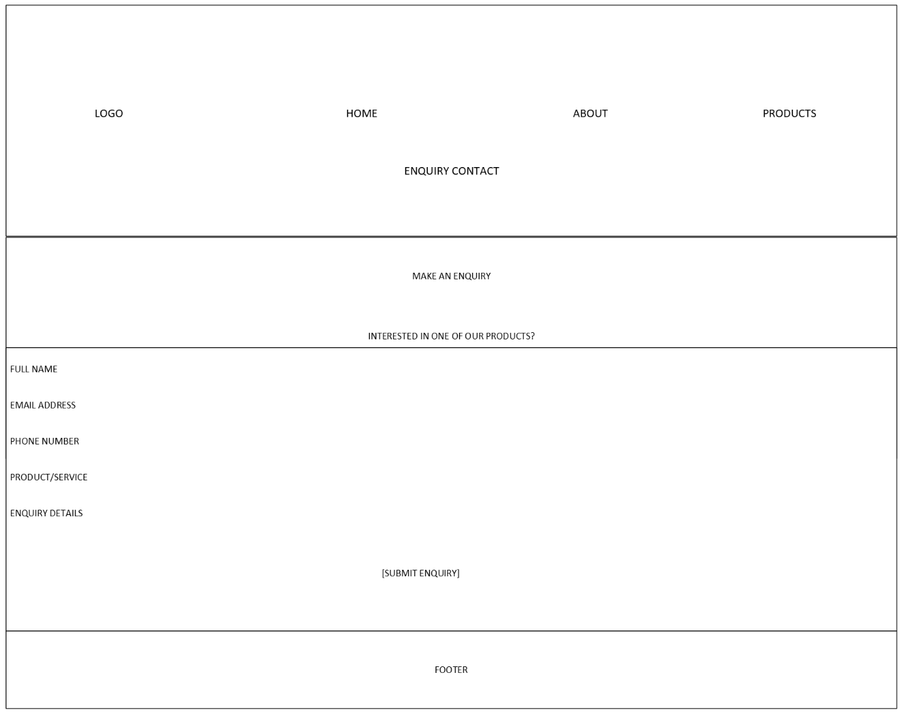
Figure 5: Home Baked Enquiry Form page wireframe

Technical Requirements
The website will be developed using:
- HTML5 for page structure.
- CSS3 for styling and responsive layouts.
- JavaScript for interaction function at its scene.
- A responsive design approach for desktop, tablet and mobile devices.
- Web hosting and suitable domain name.

Timeline and Milestones
- Research and proposal - 1 week.
- Sitemap and wireframes - 1 week.
- HTML and CSS development - 1 to 2 weeks.
- Testing, debugging and finalization - 1 week.

Budget
Item | Estimated cost
Domain | R105 yearly
Hosting | R1,188 yearly
Website Development | Student developed – R0
Maintenance | R600 yearly
Estimated initial cost | R1,893

References
- Homebased business information and online listing.
- The bugle. Historical information about home baked.
- Microsoft Visio.
- Xneelo, (2026). Domain names. Available at: < https://xneelo.co.za/domains/ > [Accessed 18 August 2026].
- Xneelo, (2026). Web hosting. Available at: < https://xneelo.co.za/web-hosting/ > [Accessed 18 August 2026]

